Aleksis Daugats

Exam project, winter 2024,  
Multimedia Design

Website solution for Aarhus Courtyards

Supervisors:  
Maria Louise Bendixen, Sergio Da Luz Benrós and Morten Algy Bonderup.

Hand-in date:  
December 19, 2024

[URL to Figma Prototype](https://www.figma.com/proto/XC6OgCvrw5fp75ta2hMfkR/Hidden-Escape-Production?page-id=35%3A98&node-id=259-803&node-type=frame&viewport=1087%2C-339%2C0.45&t=CBgHd0yKM8gb1UZh-1&scaling=scale-down&content-scaling=fixed&starting-point-node-id=259%3A826) [URL to coded solution](https://justmangoo.github.io/Aarhus-Courtyards/) [URL to GitHub repository](https://github.com/JustMangoo/Aarhus-Courtyards)

# Table of content

Introduction 2

1. Research and Mapping 2

1.1.1. Interviews and User Groups 2

1.2. Mapping 3

1.2.1. User Persona and User Page 3

1.2.2. Values Proposition 5

1.2.3. Object Oriented User Experience (OOUX) 7

1.2.4. List of requirements 7

1.2.5. List of values 8

2. Design 10

2.1. Mind Map 10

2.2. Sketching 10

2.3. Lo-fi wireframe 12

2.4. Mood board 14

2.5. Style tile 15

2.6. Hi-fi prototype 16

2.6.1. Hi-fi testing and feedback 18

3. Programming 19

4. Sources 22

4.1.1. Models, Methods, and Theories 22

4.1.2. Technical Resources 22

5. Appendix 23

# Introduction

Imagine stumbling upon a secret garden in the middle of the city. A peaceful retreat, a hidden gem. That's what this project is all about! This platform is meant to help you discover these urban oases, share your favorites with a community of like-minded people, and connect with the nature right outside your door.

Think of it as a treasure map for city dwellers. A place to find calm and escape, and a bit of nature in the heart of the hustle and bustle. The platform will be accessible to everyone, with multilingual support and clear navigation tools. The aim was to create a calming and focused experience.

# Research and Mapping

The initial phase focused on understanding user needs and preferences related to relaxation and hidden spaces within the urban environment. This involved conducting user interviews to gather qualitative data and identify key attributes for the platform.

### Interviews and User Groups

To understand user experiences and preferences, interviews were conducted using a structured guide [Fig 1]. Eight participants representing diverse demographics in Aarhus were interviewed to gather qualitative data. The interviews revealed a strong appreciation for natural elements, a desire for quiet escapes, and challenges in finding hidden spaces.

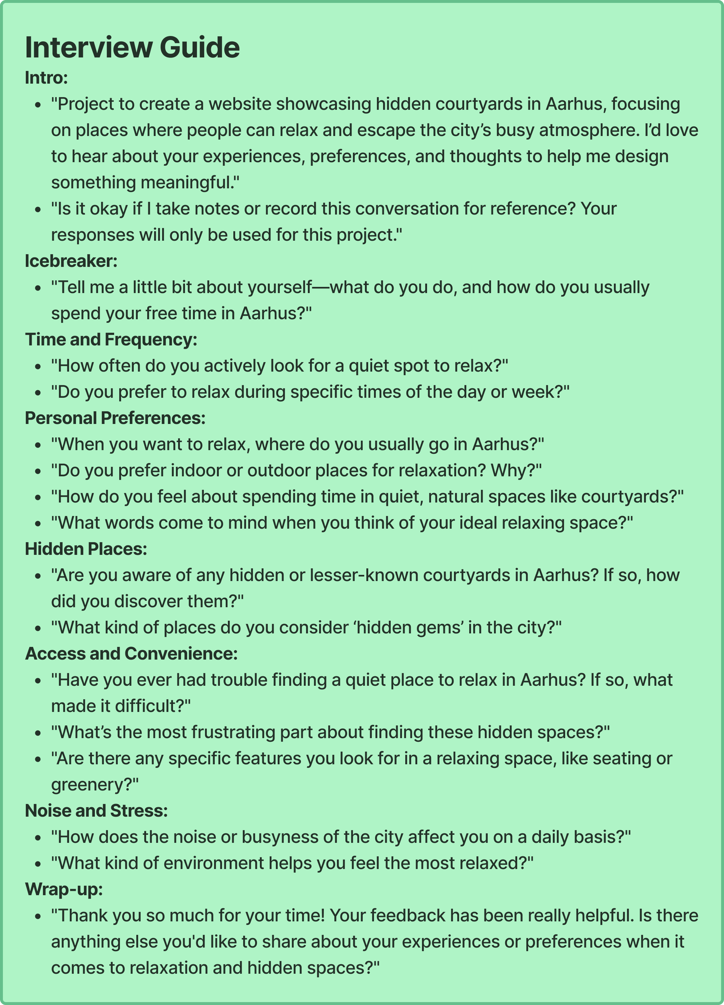

[Fig 1: Interview guide]

## Mapping

With a clearer understanding of user needs from the interviews, the next step was to map out the key aspects of the platform. This included defining user personas, establishing the value proposition, structuring the user experience with OOUX, and outlining the project's requirements and core values. This section details how these elements were defined to create a solid foundation for the design and development phases.

### User Persona and User Page

To better understand the target audience, a primary user persona, "Freya Larsen," was developed. Freya represents a young professional seeking urban relaxation. She is a creative individual who values quiet moments and enjoys exploring cozy spaces with friends. The User Persona page, visualized in [Fig 2], provides a detailed overview of Freya's demographics, lifestyle, motivations, and goals when using the Aarhus Courtyards platform.

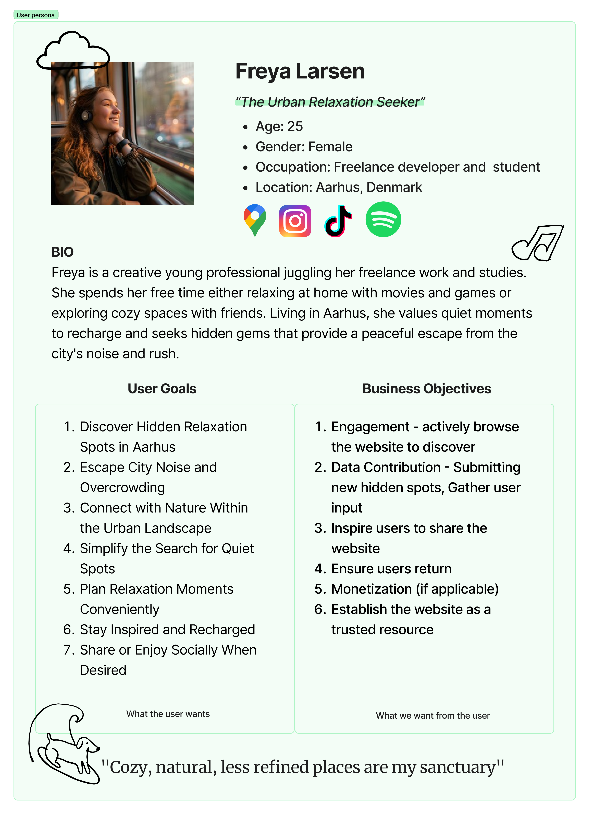

[Fig 2: User persona]

### Values Proposition

A value proposition canvas [Fig 3] was used to map out the needs, wants, and fears of our users against the benefits and features of the Aarhus Courtyards platform. This exercise helped to identify the sweet spot where the platform best meets the needs of city dwellers seeking relaxation and escape.

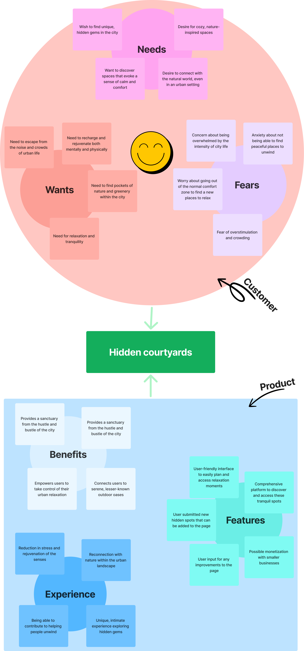

[Fig 3: Value proposition canvas]

### Object Oriented User Experience (OOUX)

To better structure the information and interactions within the Aarhus Courtyards platform, an Object-Oriented User Experience (OOUX) approach was used. This involved defining key objects such as "Courtyards," "Users," and "Reviews," and mapping out their attributes and relationships. This OOUX model [Fig 4] provided a clear framework for designing the platform's architecture and functionality.

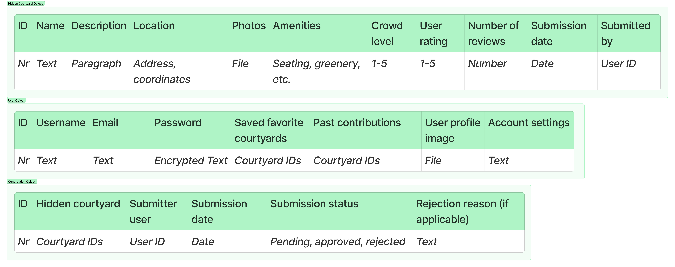

[Fig 4: OOUX diagrams]

### List of requirements

The project outlined a set of requirements [Fig 5] to ensure the Aarhus Courtyards platform meets user needs and provides a valuable experience. These requirements cover a range of aspects, including device compatibility, accessibility features, user-friendly navigation, customization options, and a robust backend for data management.

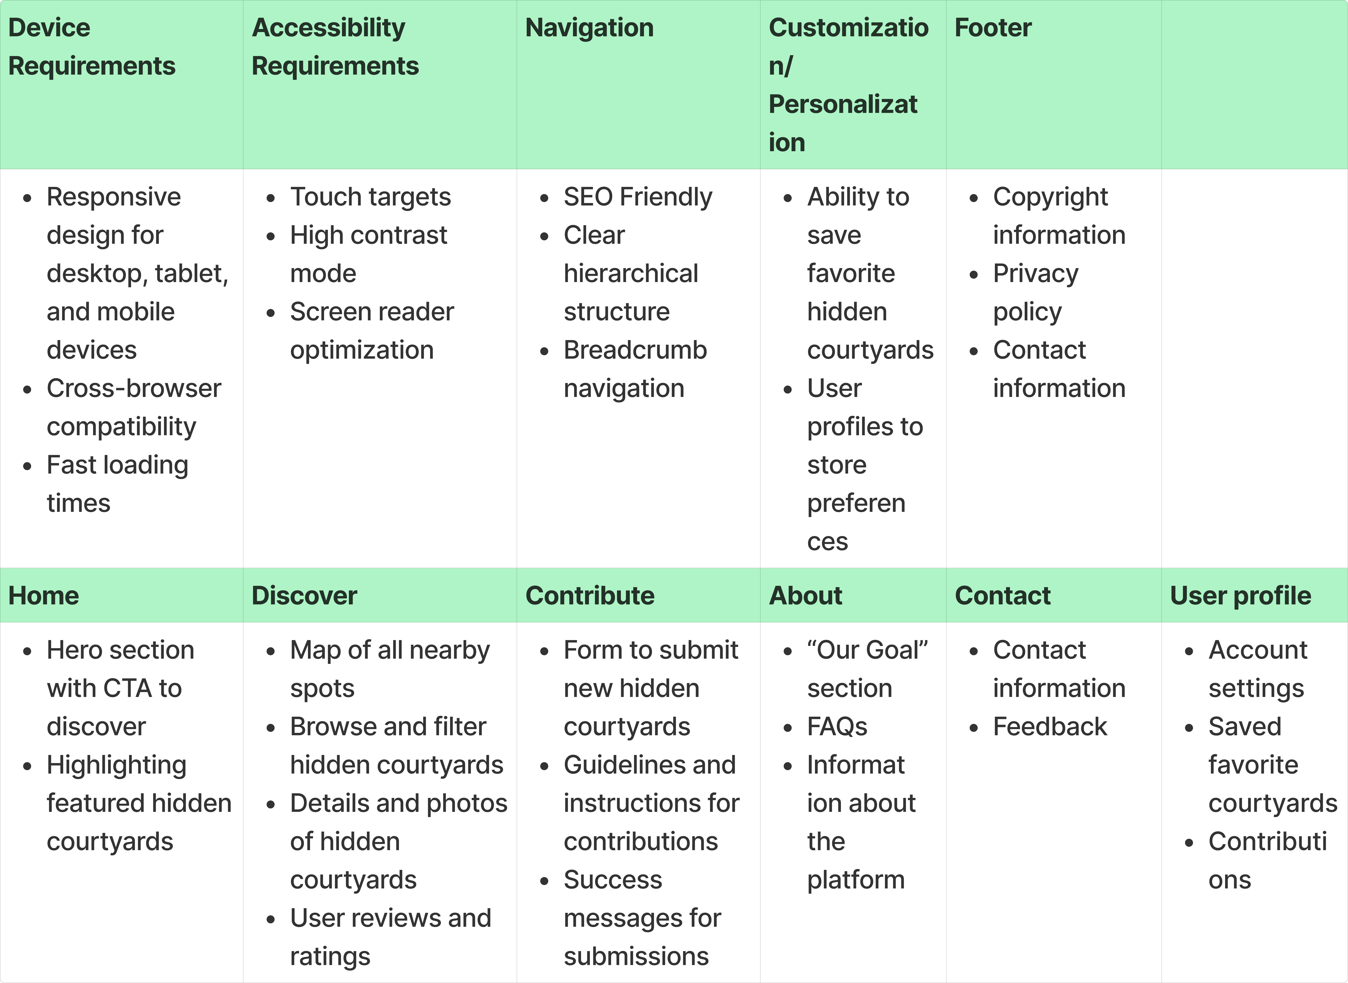

[Fig 5: Requirements list]

### List of values

To ensure the Aarhus Courtyards platform truly reflects its purpose, a list of six core values was established. This involved brainstorming and visualizing a word cloud [Fig 6] of relevant values, including "Discovery," "Nature," "Escape," "Community," "Accessibility," and "Calming." These values guided the project throughout, ensuring the platform prioritizes user experience, fosters a sense of community, and celebrates the unique beauty of hidden urban spaces.

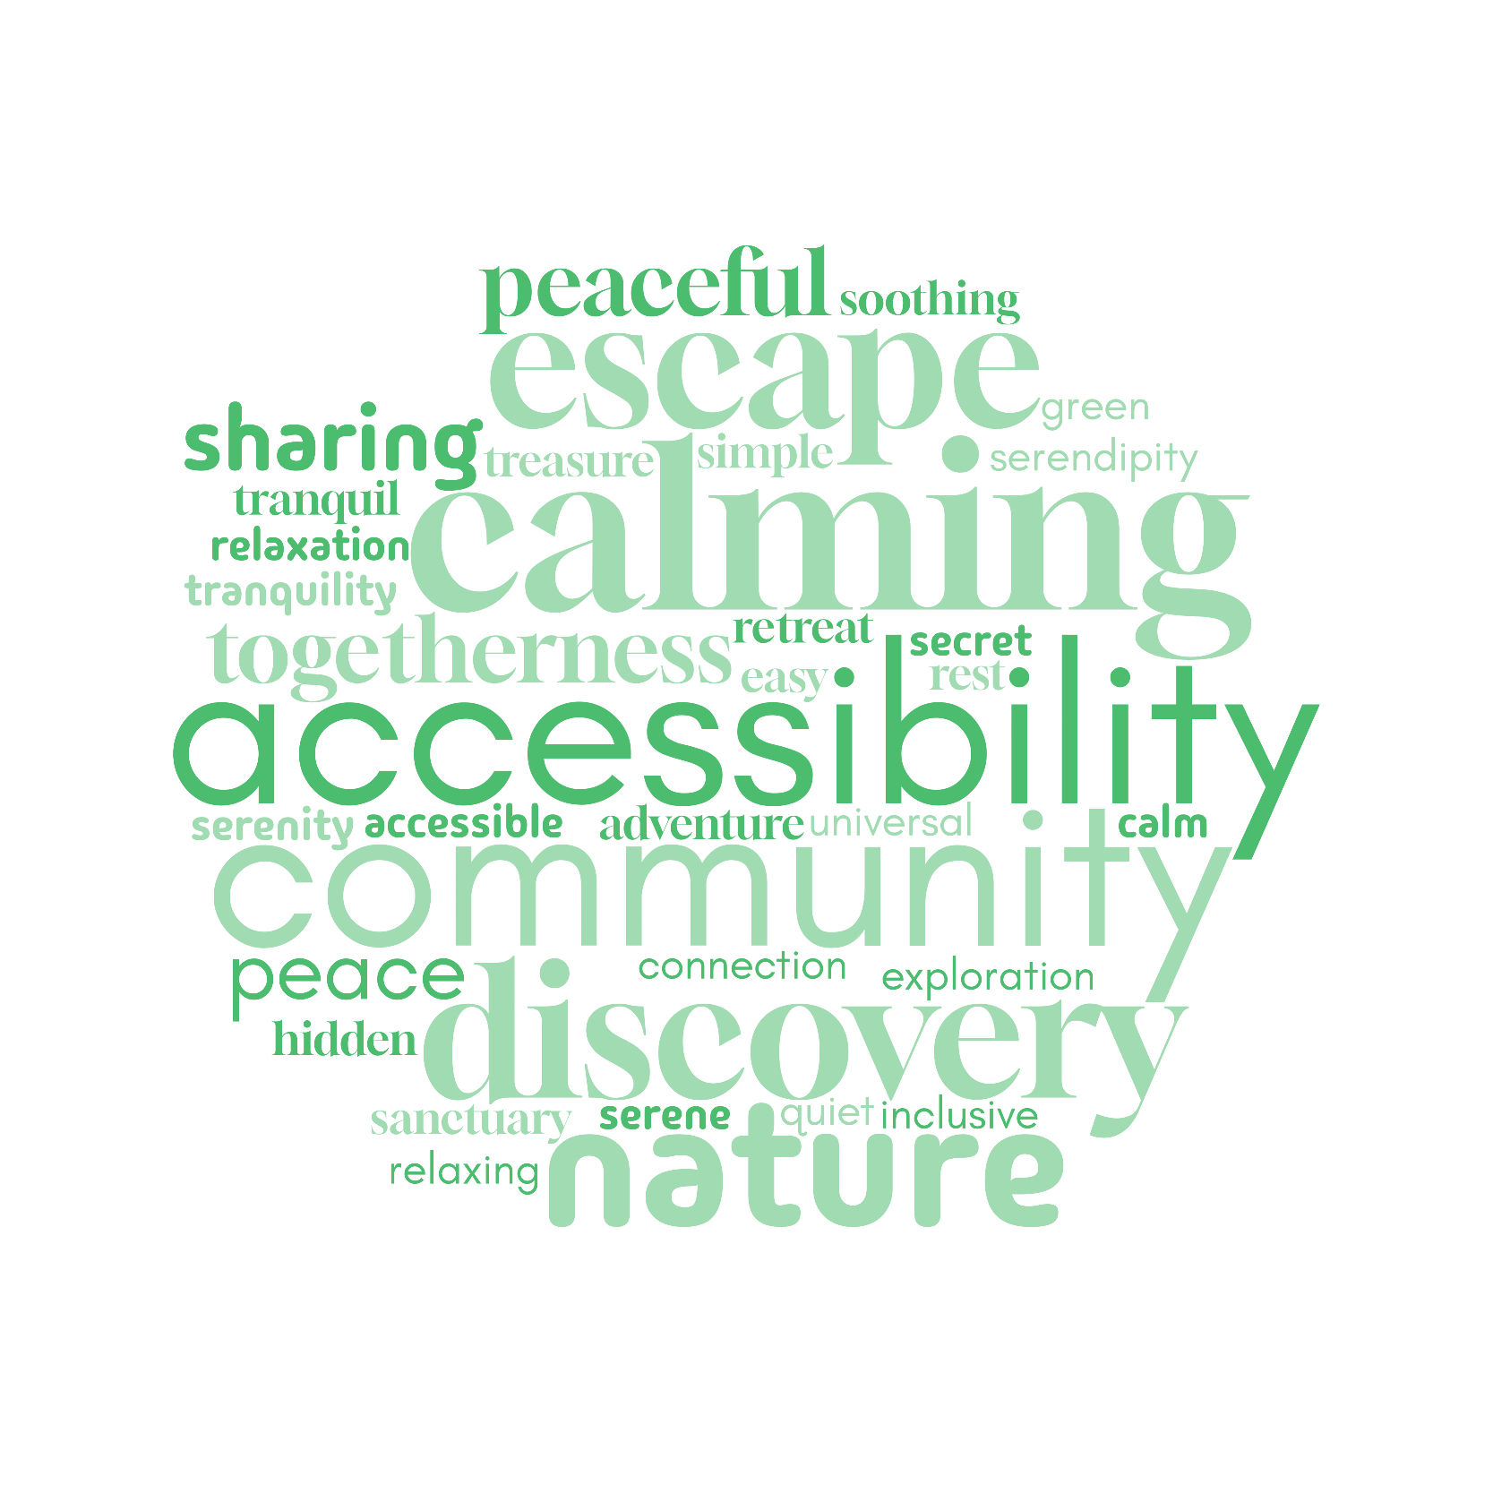

[Fig 6: Value word cloud]

# Design

The design phase was an iterative process that involved exploring various creative avenues. This included brainstorming ideas with mind maps, sketching initial concepts, creating low-fidelity wireframes to test layouts, and developing a comprehensive mood board to define the visual style. The culmination of this design process resulted in a high-fidelity prototype, which was then tested with users to gather feedback and refine the design further.

## Mind Map

The design process began with a brainstorming session using a mind map to visually explore ideas and connections. Starting with the core concept of "Hidden Courtyards," branches were drawn to represent key features, user experiences, and design considerations. This exercise helped to identify key themes and potential directions for the platform's design. [Fig 7]



[Fig 7: Mind map]

## Sketching

The mind map was used to generate initial concepts, which were then explored through rapid sketching. Using the Crazy 8 method [Fig 8], eight quick sketches were created for both mobile and desktop versions of the platform. This iterative sketching process helped to refine ideas and explore different layout options, leading to a better understanding of the user interface and user flow. For example, early sketches explored different navigation patterns and visual hierarchies.

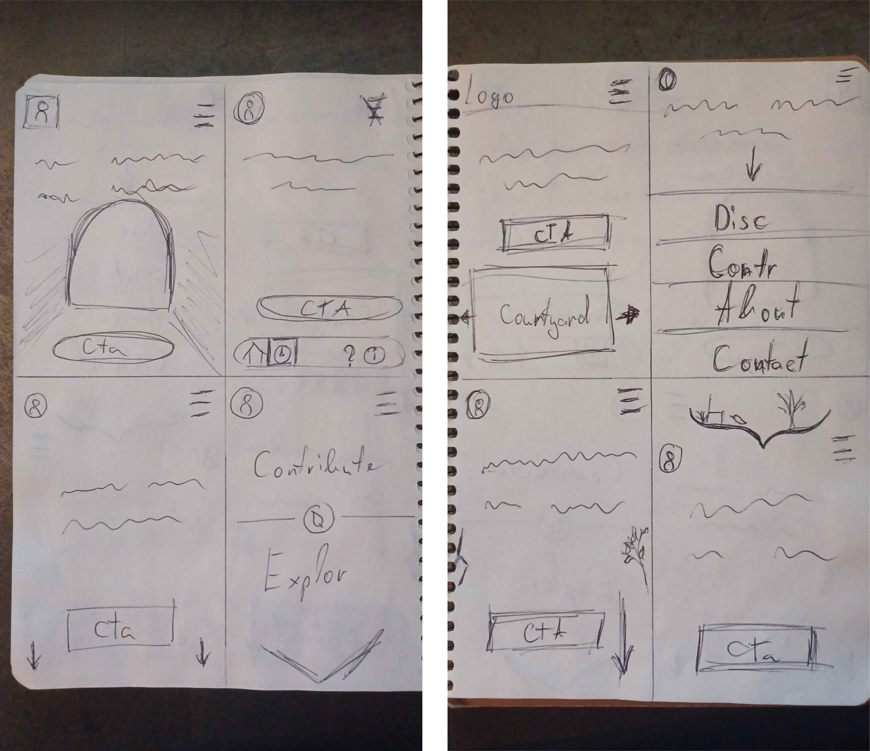

[Fig 8: Hand-drawn mobile Crazy 8]

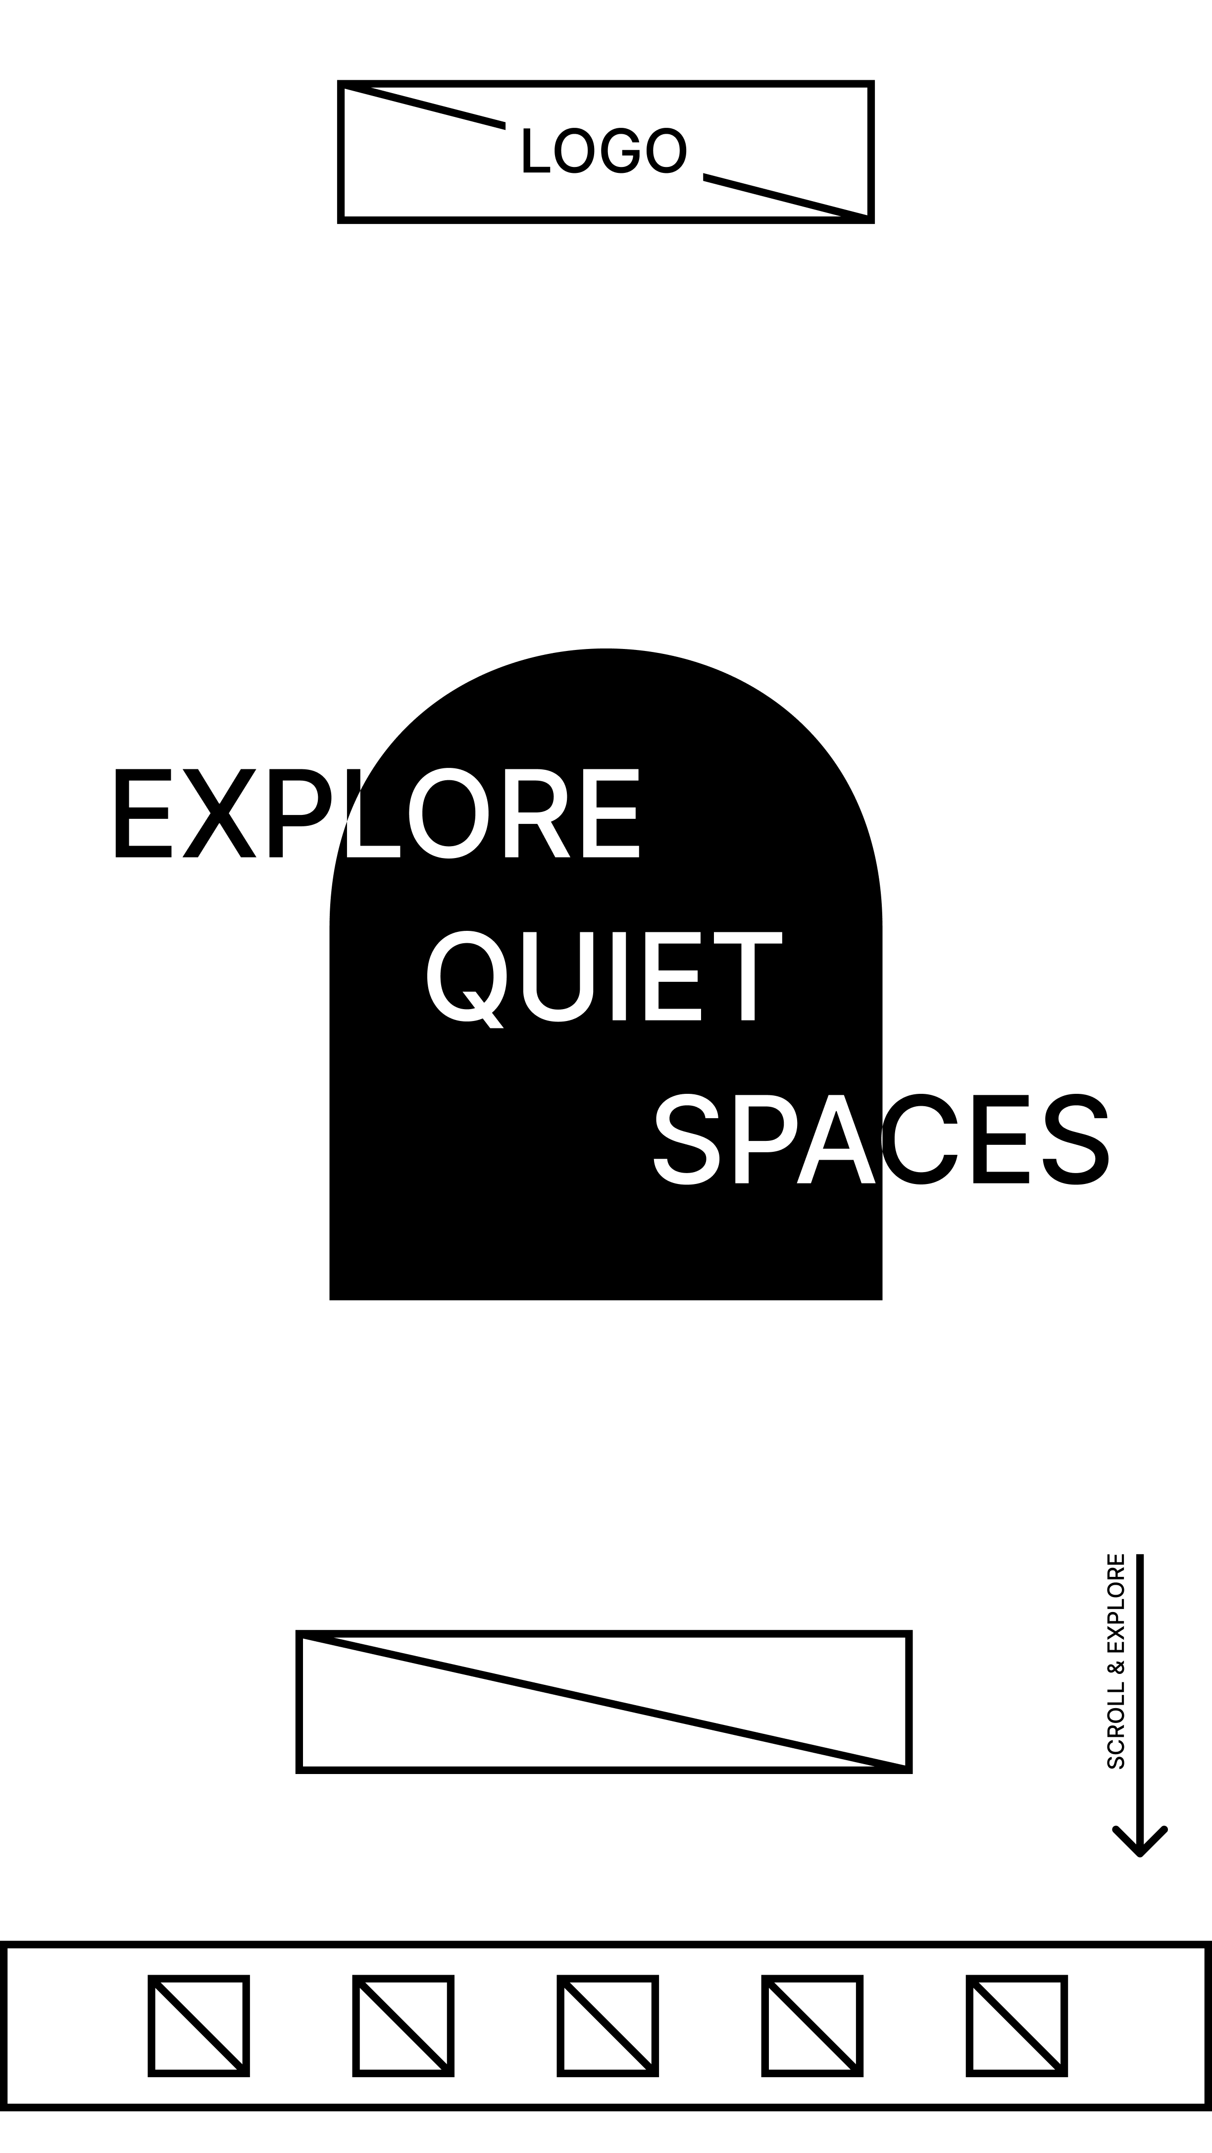

[Fig 9: Digital mobile sketch]

## Lo-fi wireframe

Building on the initial sketches, low-fidelity wireframes [Fig 10] [Fig 11] were created in Figma designer using simple shapes and grayscale to focus on the overall layout and information architecture. This iterative process involved testing different navigation options, content placements, and user flows to ensure the platform was intuitive and easy to use.

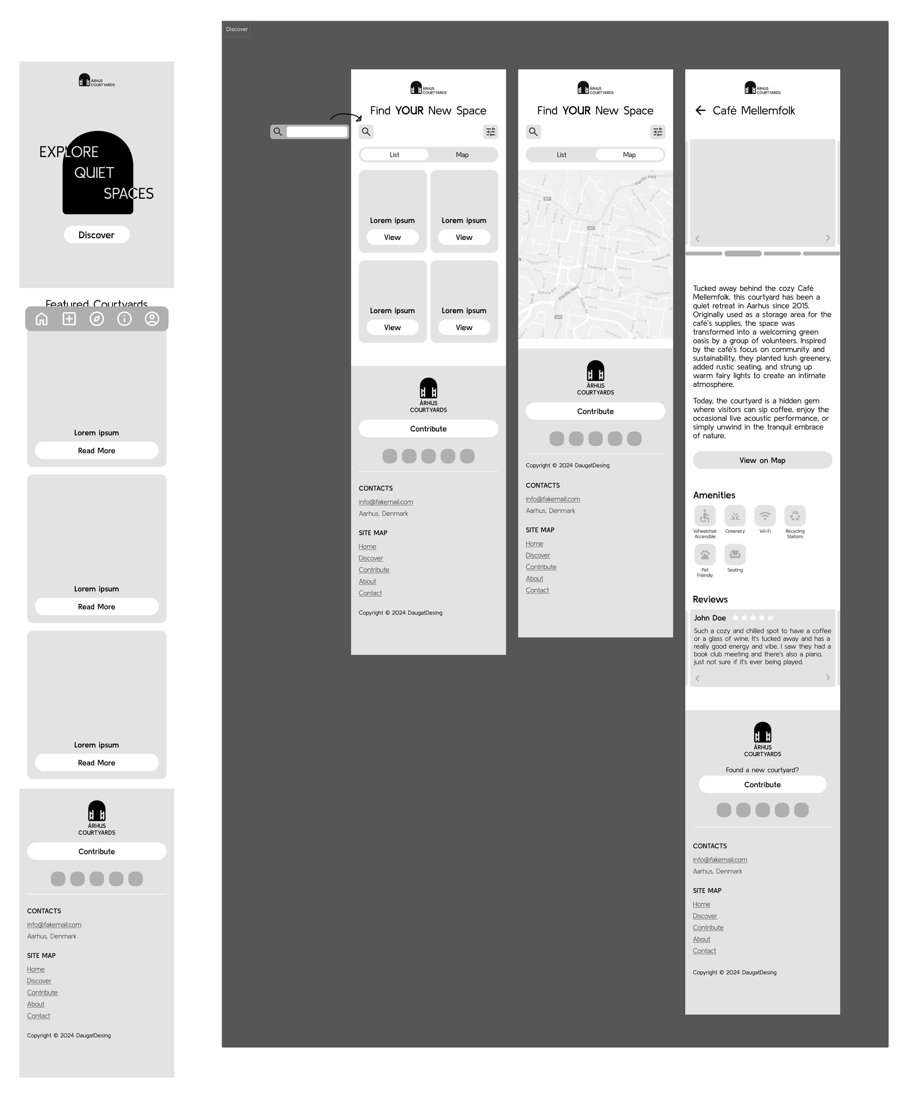

[Fig 10: Lo-fi mobile wireframe snippet]

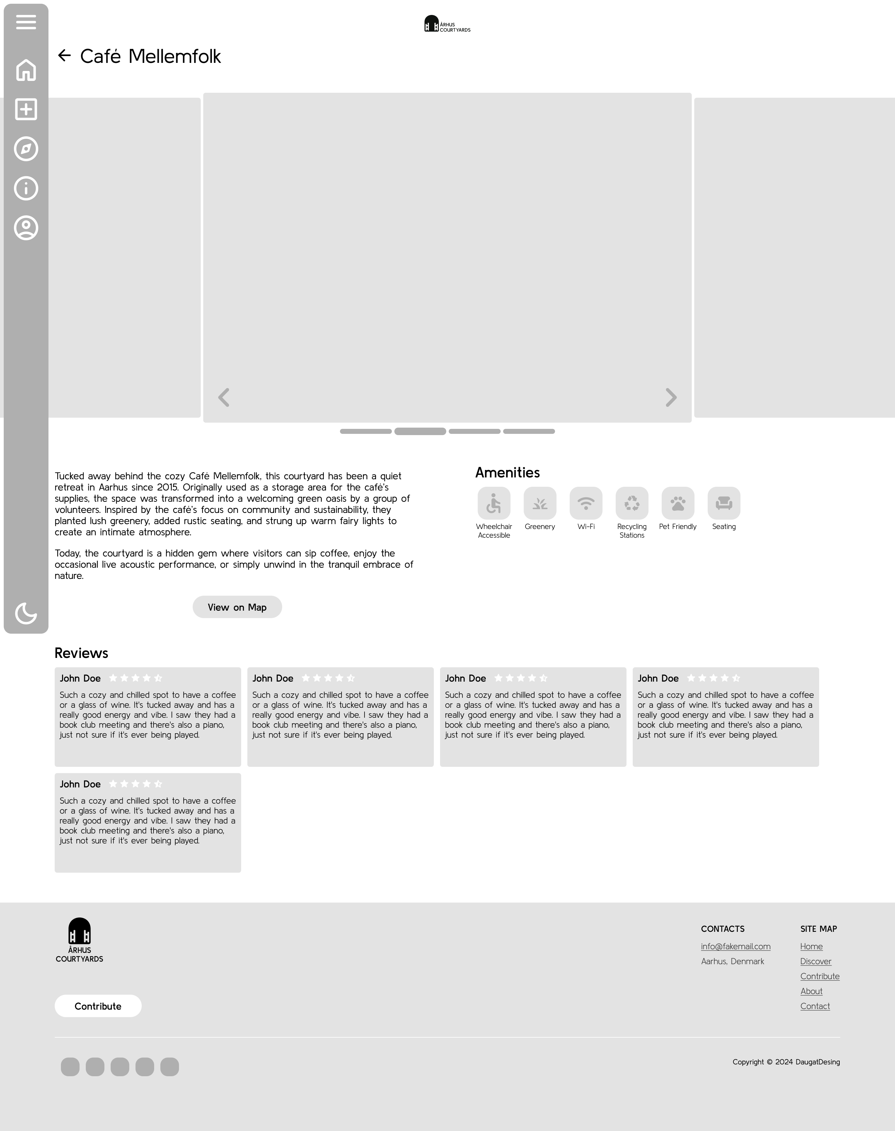

[Fig 11: Lo-fi desktop wireframe snippet]

## Mood board

To establish a consistent visual identity for the Aarhus Courtyards platform, a mood board was created [Fig 12]. This involved gathering images that evoked the desired atmosphere and aesthetic, such as photos of serene courtyards, lush greenery, and natural textures. The mood board served as a visual reference for the color palette, typography choices, and overall visual style of the platform.

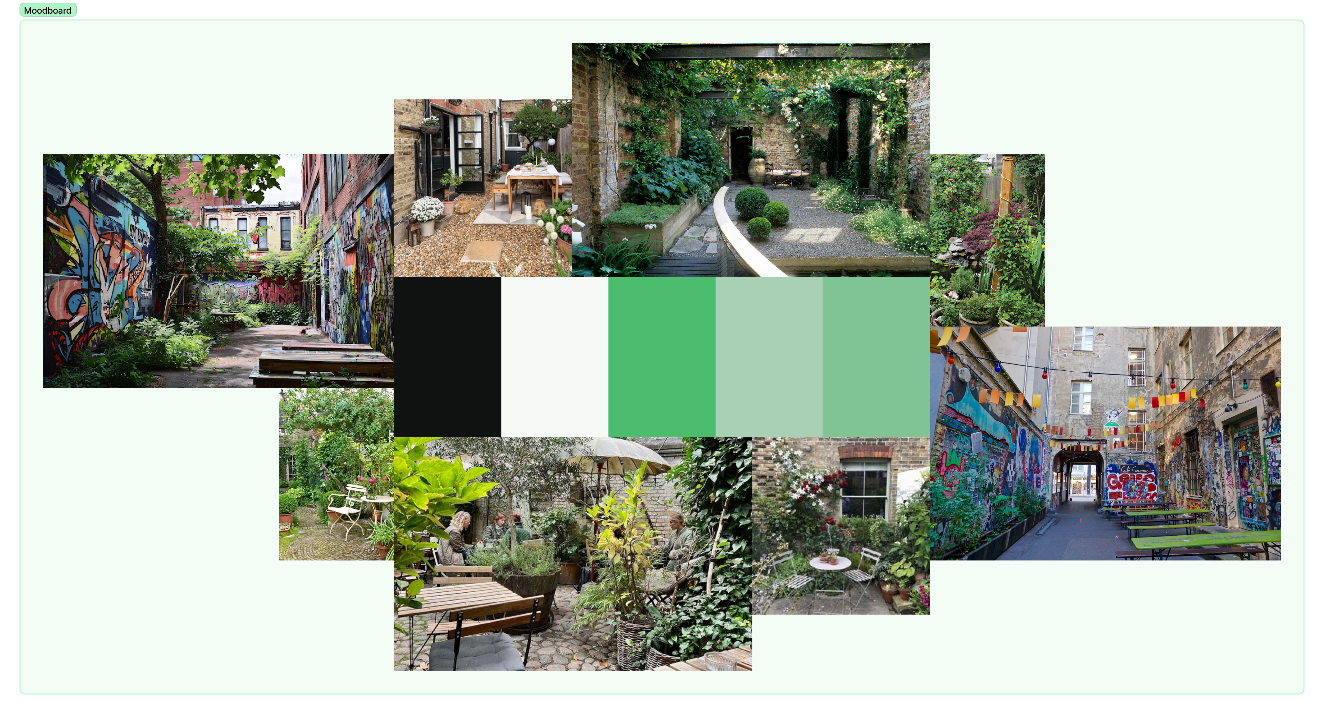

[Fig 12: Mood board]

## Style tile

The style tile was created [Fig 13] to ensure consistency in the visual language of the Aarhus Courtyards platform. This involved defining a color palette inspired by nature, selecting a clear and readable typeface, and establishing a consistent style for buttons, icons, and other UI elements. The style tile served as a reference guide throughout the design and development process, ensuring a cohesive and visually appealing user experience. It also prominently displays the core values of the platform - Nature, Escape, Calming, Discovery, Community, and Accessibility.

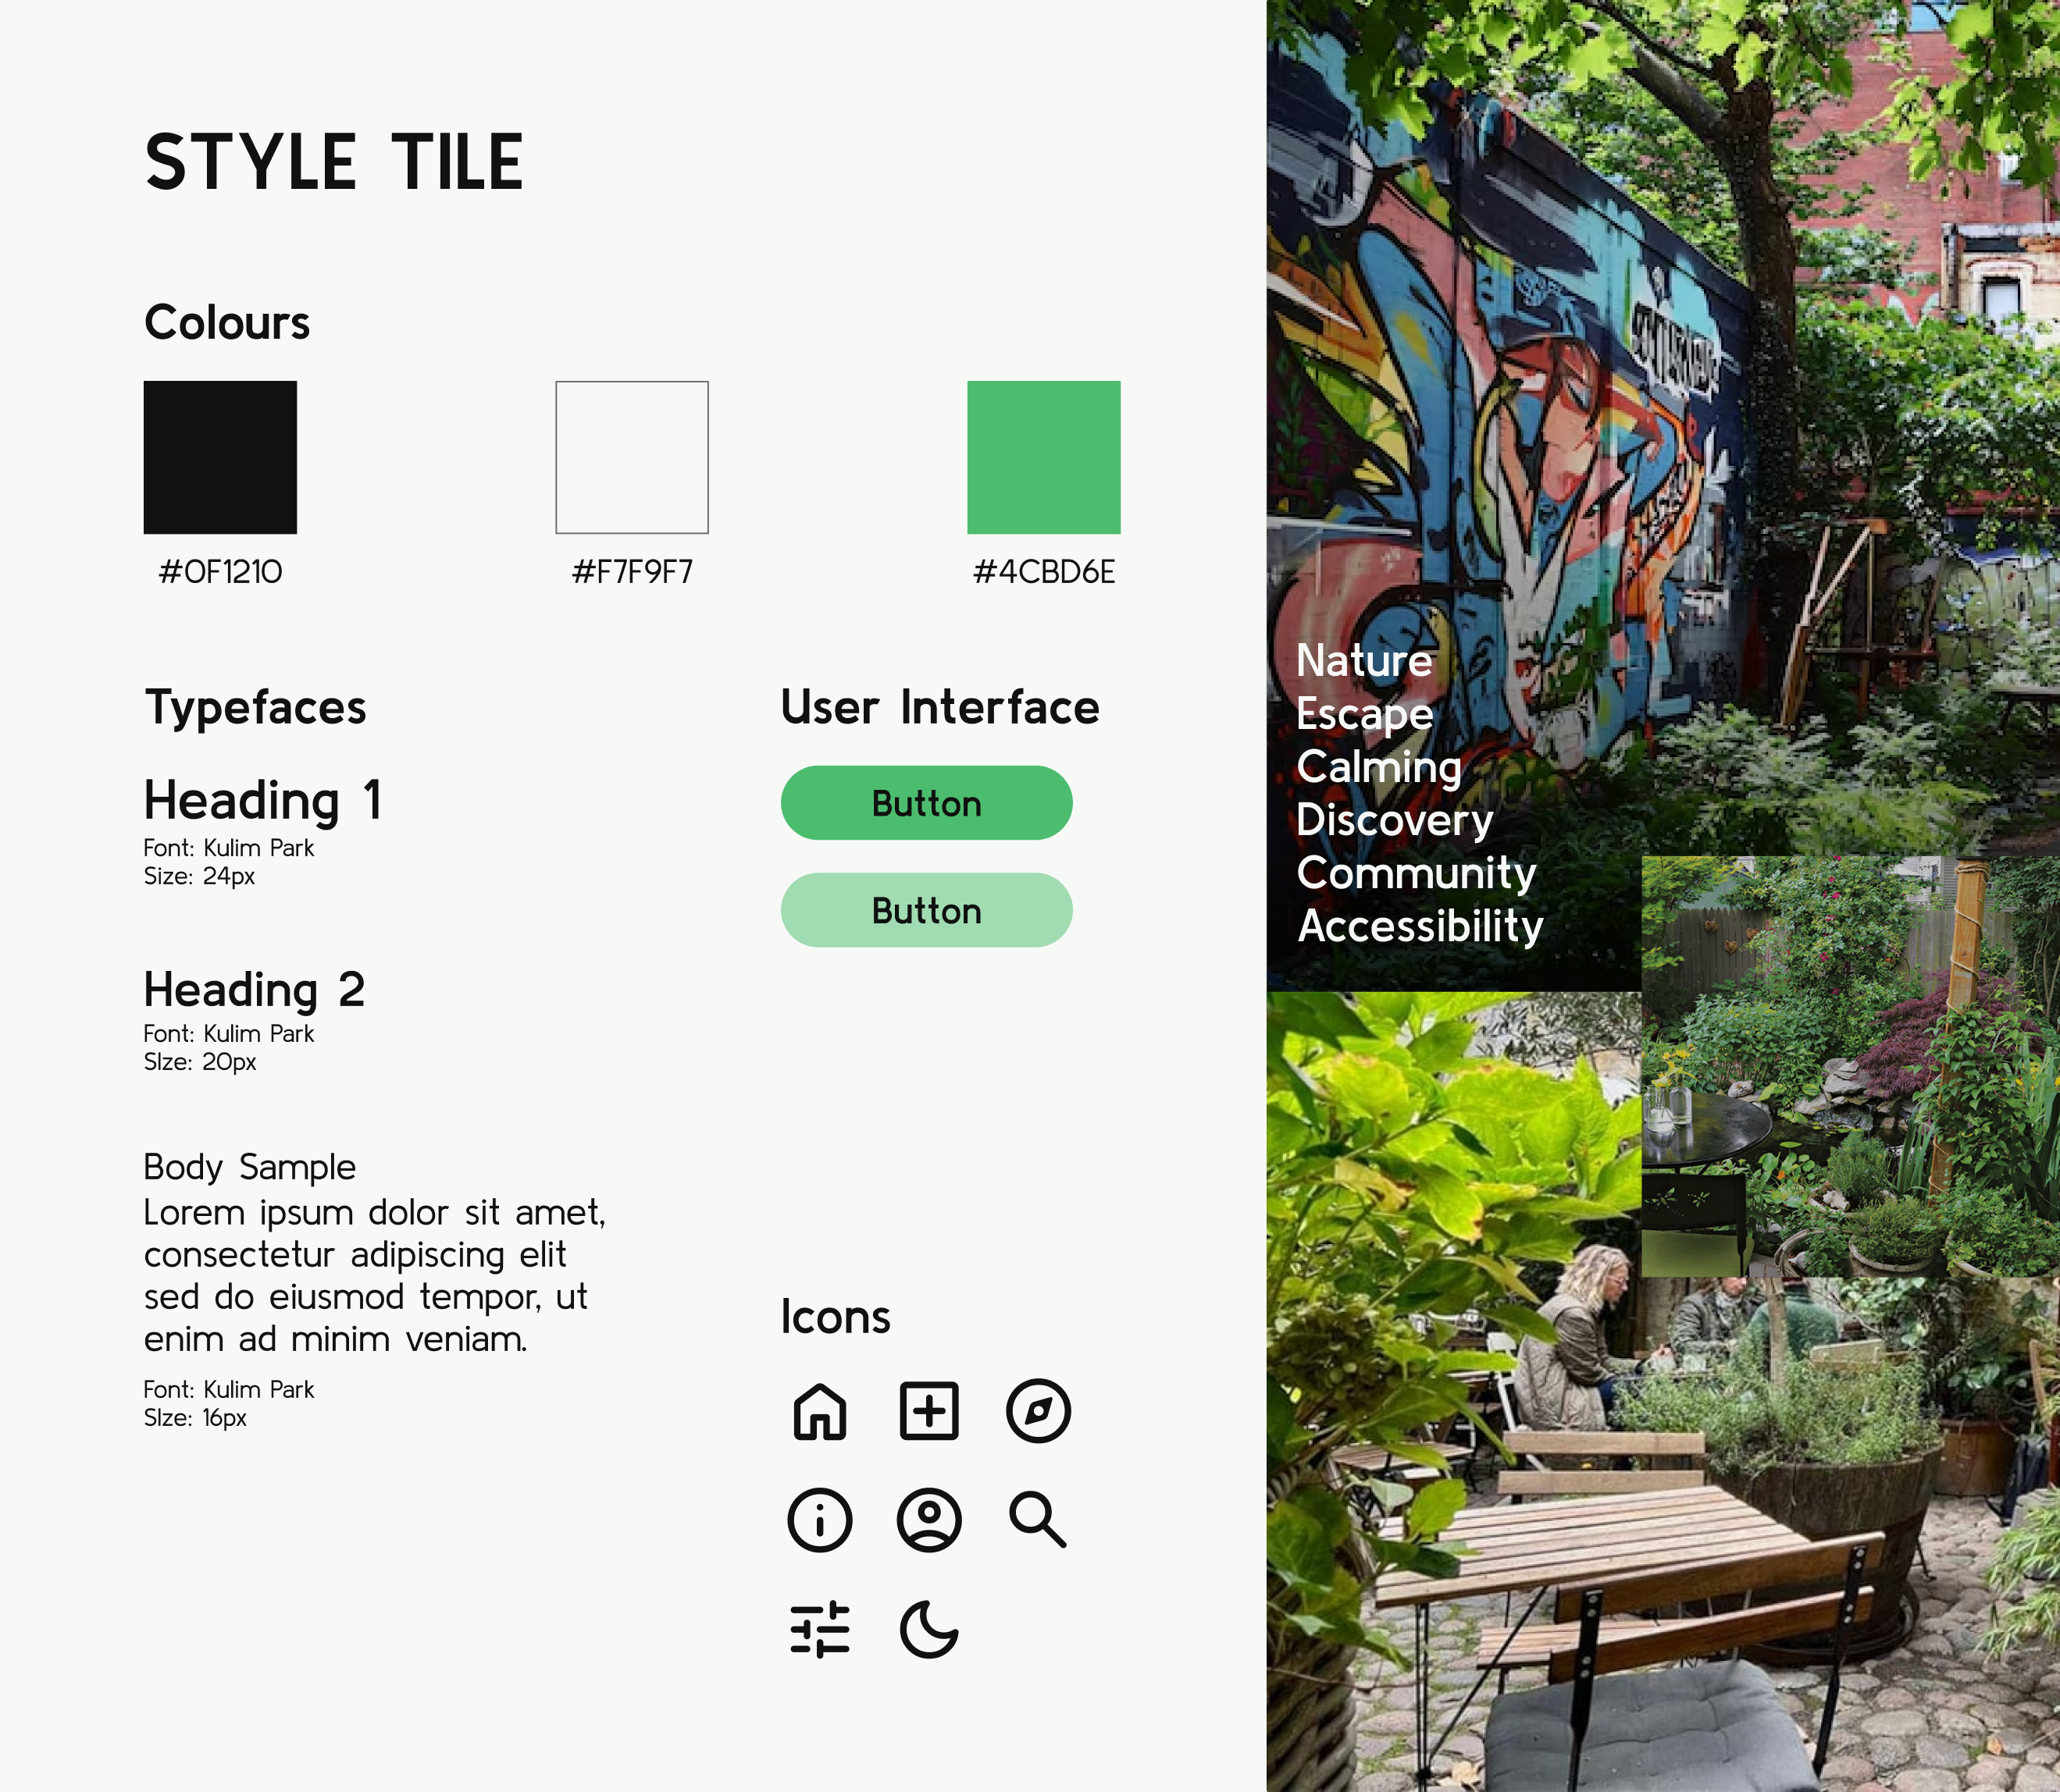

[Fig 13: Style tile]

## Hi-fi prototype

Building upon the lo-fi wireframes and guided by the established style tile, a high-fidelity interactive prototype was created [Fig 14] [Fig 15]. This involved translating the design concepts into a visually polished and functional interface, paying close attention to details like typography, color usage, and micro-interactions. The prototype aimed to simulate the user experience as closely as possible, allowing for further testing and refinement.

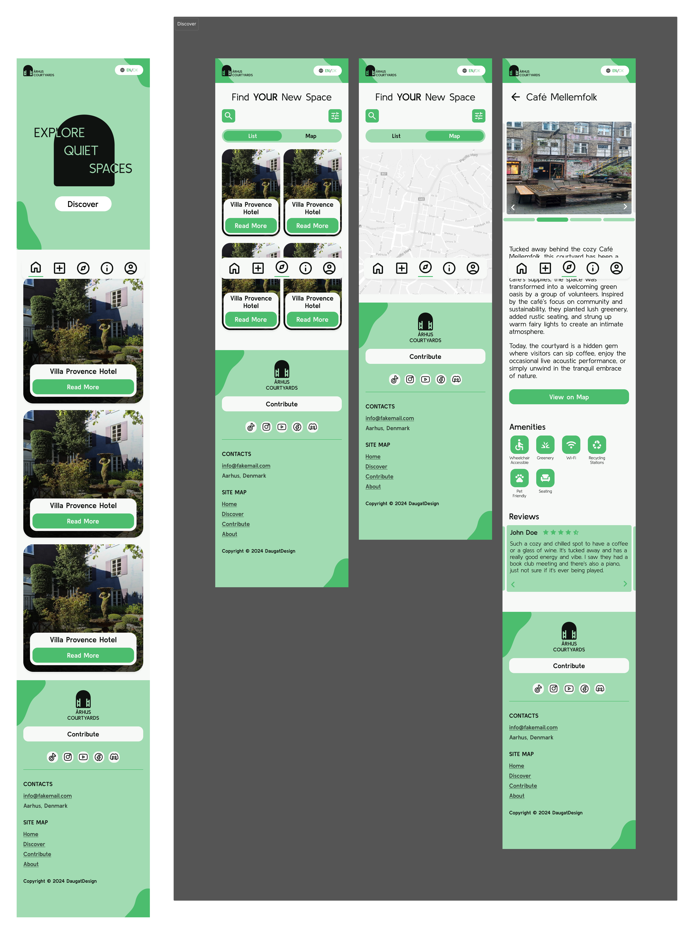

[Fig 14: Hi-fi mobile prototype snippet]

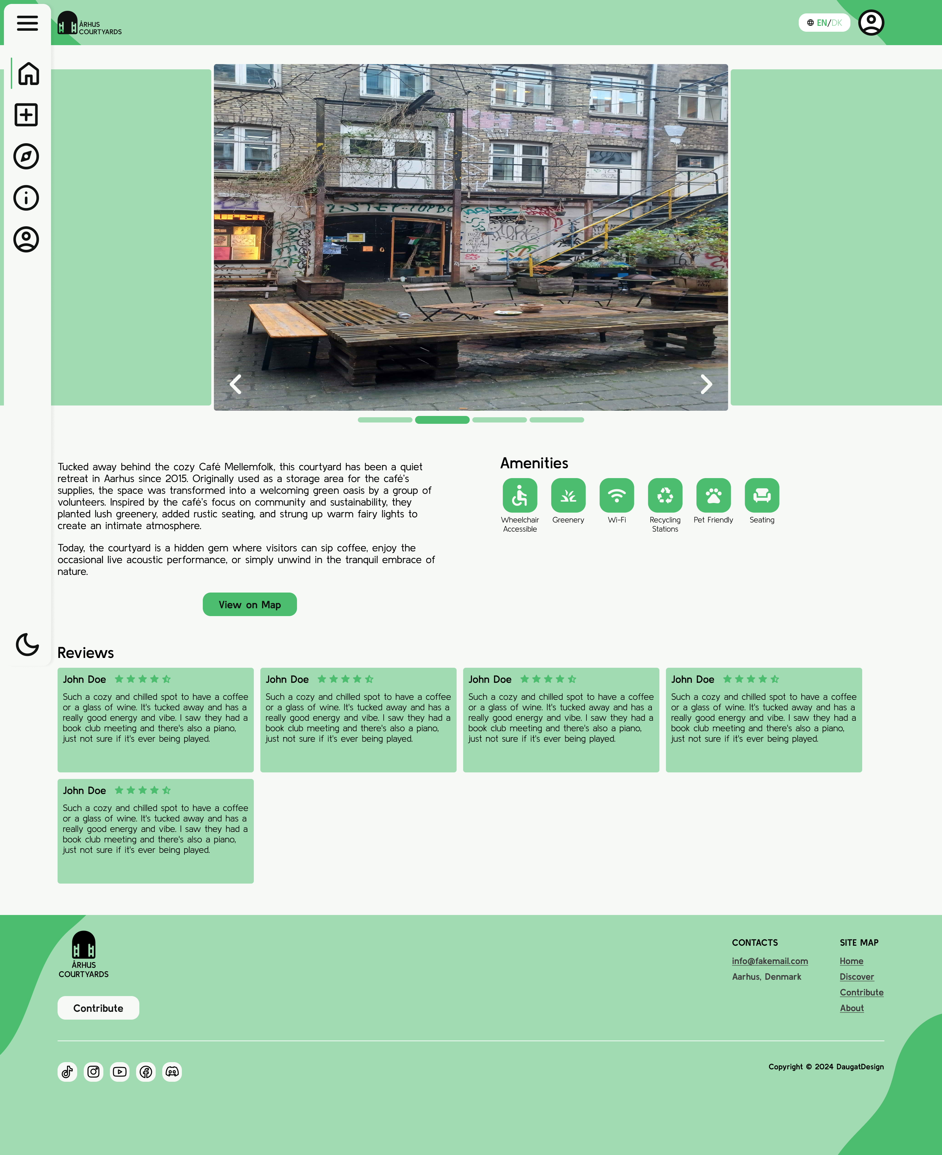

[Fig 15: Hi-fi desktop prototype snippet]

### Hi-fi testing and feedback

The high-fidelity prototype was presented to users for testing and feedback. This process provided valuable insights into the user experience, revealing both strengths and areas for improvement in the design, such as menu placement and information discoverability. [Fig 13]

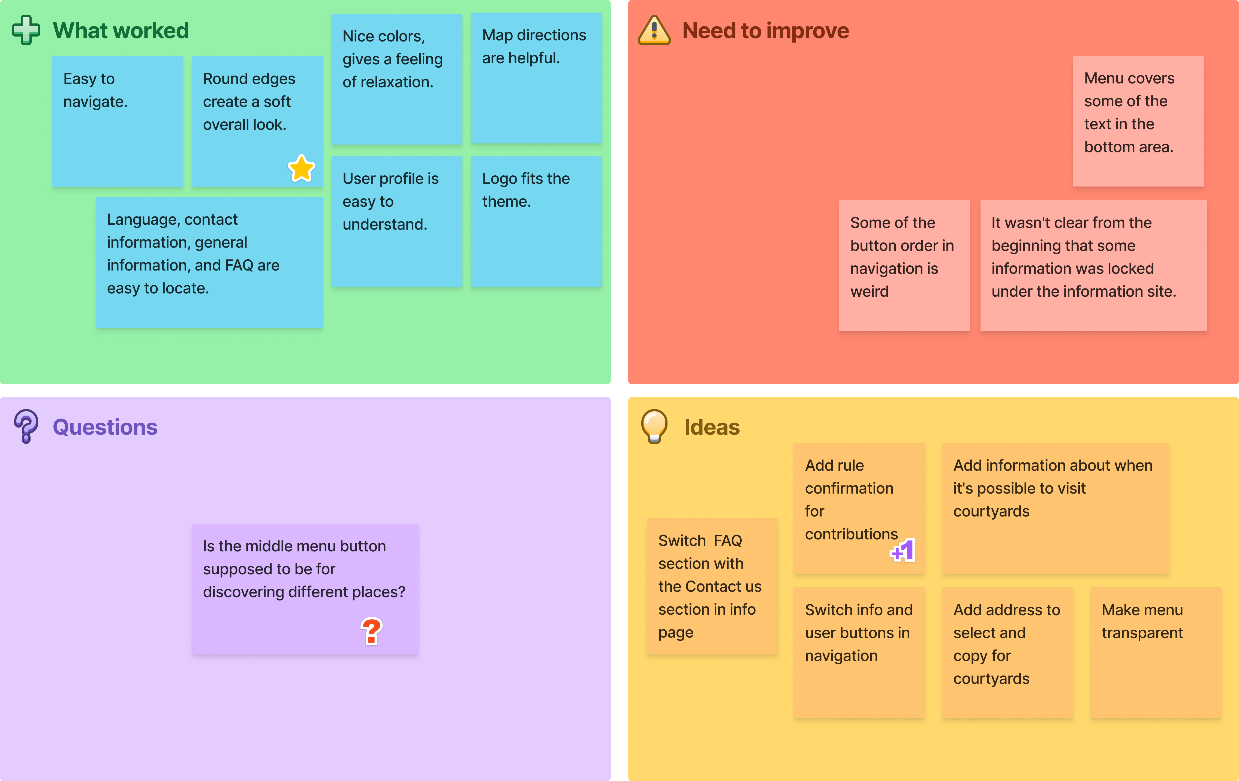

[Fig 13: Feedback grid]

# Programming

The project's front-end was built using HTML for structure, CSS for styling derived from Figma's dev mode, and JavaScript for interactivity. The JavaScript implementation involved separate scripts for carousel functionality, map integration (not detailed in our previous exchanges, but mentioned in your image), popup handling, and view changes, promoting modularity and maintainability. [Fig 14] [Fig 15]

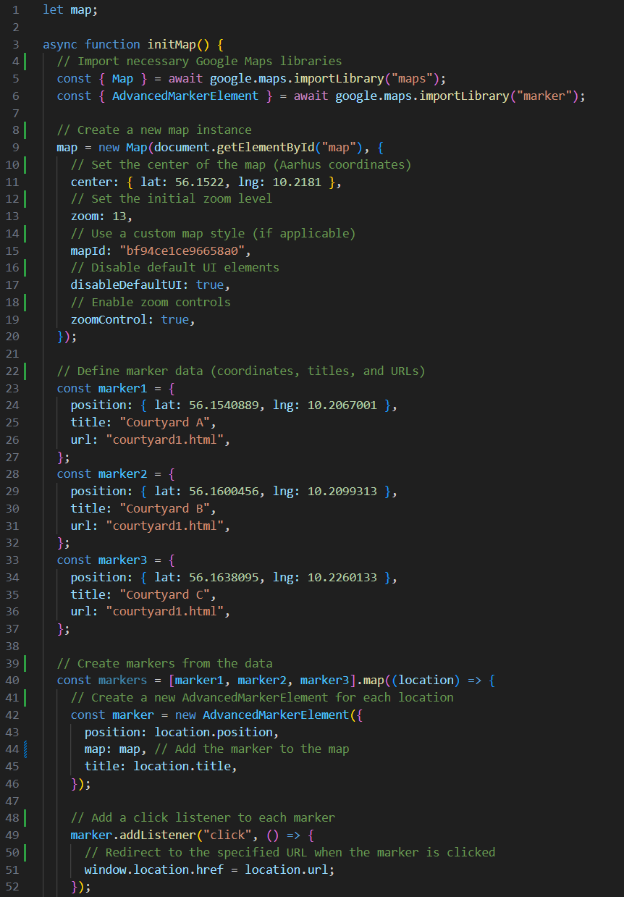

[Fig 14: Map Implementation Code]

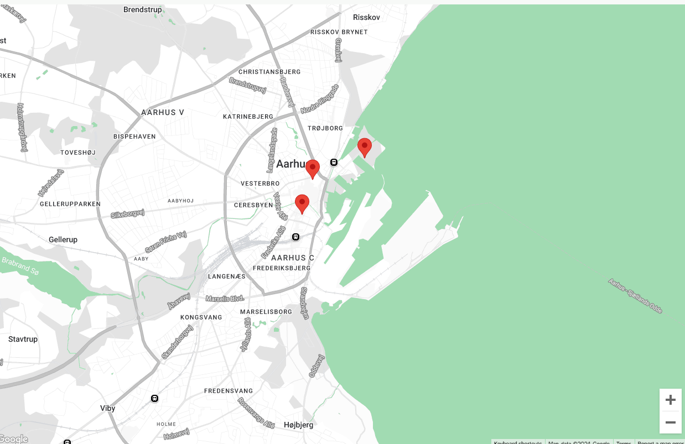

[Fig 15: Map Implementation Output]

# Sources

This section lists all the sources referenced in this report.

### Models, Methods, and Theories

* **Affinity Diagramming:**   
  Interaction Design Foundation. *Affinity Diagrams*. [online] Available at:  [https://www.interaction-design.org/literature/topics/affinity-diagrams](https://www.interaction-design.org/literature/topics/affinity-diagrams%20) [Accessed 20 Nov. 2024].
* **Hi-fi and Lo-fi Prototyping:**       
  Interaction Design Foundation. (n.d.). Prototyping. [online] Available at: <https://www.interaction-design.org/literature/topics/prototyping> [Accessed 20 Nov. 2024].
* **Mind Mapping:**       
  Mindmapping.com. What is a Mind Map?. [online] Available at: [https://www.mindmapping.com/mind-map](https://www.mindmapping.com/mind-map%20) [Accessed 20 Nov. 2024].
* **Object-Oriented User Experience (OOUX):**       
  OOUX.com. Object-Oriented UX. [online] Available at: [https://www.ooux.com/](https://www.google.com/url?sa=E&source=gmail&q=https://www.ooux.com/) [Accessed 20 Nov. 2024].
* **Persona:**       
  Interaction Design Foundation. Personas. [online] Available at: [https://www.interaction-design.org/literature/topics/personas](https://www.google.com/url?sa=E&source=gmail&q=https://www.interaction-design.org/literature/topics/personas) [Accessed 20 Nov. 2024].
* **Mood Board:**       
  99designs. How to Create a Mood Board. [online] Available at: [https://99designs.com/blog/tips/how-to-create-a-mood-board/](https://www.google.com/url?sa=E&source=gmail&q=https://99designs.com/blog/tips/how-to-create-a-mood-board/) [Accessed 20 Nov. 2024].
* **Style Tile:**       
  Styletil.es. Style Tiles. [online] Available at: [http://styletil.es/](https://www.google.com/url?sa=E&source=gmail&q=http://styletil.es/) [Accessed 20 Nov. 2024].
* **Value Proposition Canvas:**       
  Strategyzer. *The Value Proposition Canvas*. [online] Available at: <https://www.strategyzer.com/canvas/value-proposition-canvas> [Accessed 20 Nov. 2024].

### Technical Resources

* **Google Maps Platform:**   
  Available at: [https://developers.google.com/maps](https://developers.google.com/maps%20) [Last accessed 19 Dec. 2024].
* **Figma:**       
  Available at: [https://www.figma.com/](https://www.figma.com/%20) [Last accessed 19 Dec. 2024].
* **FigJam:**       
  Available at: <https://www.figma.com/figjam/> [Last accessed 19 Dec. 2024].

# Appendix

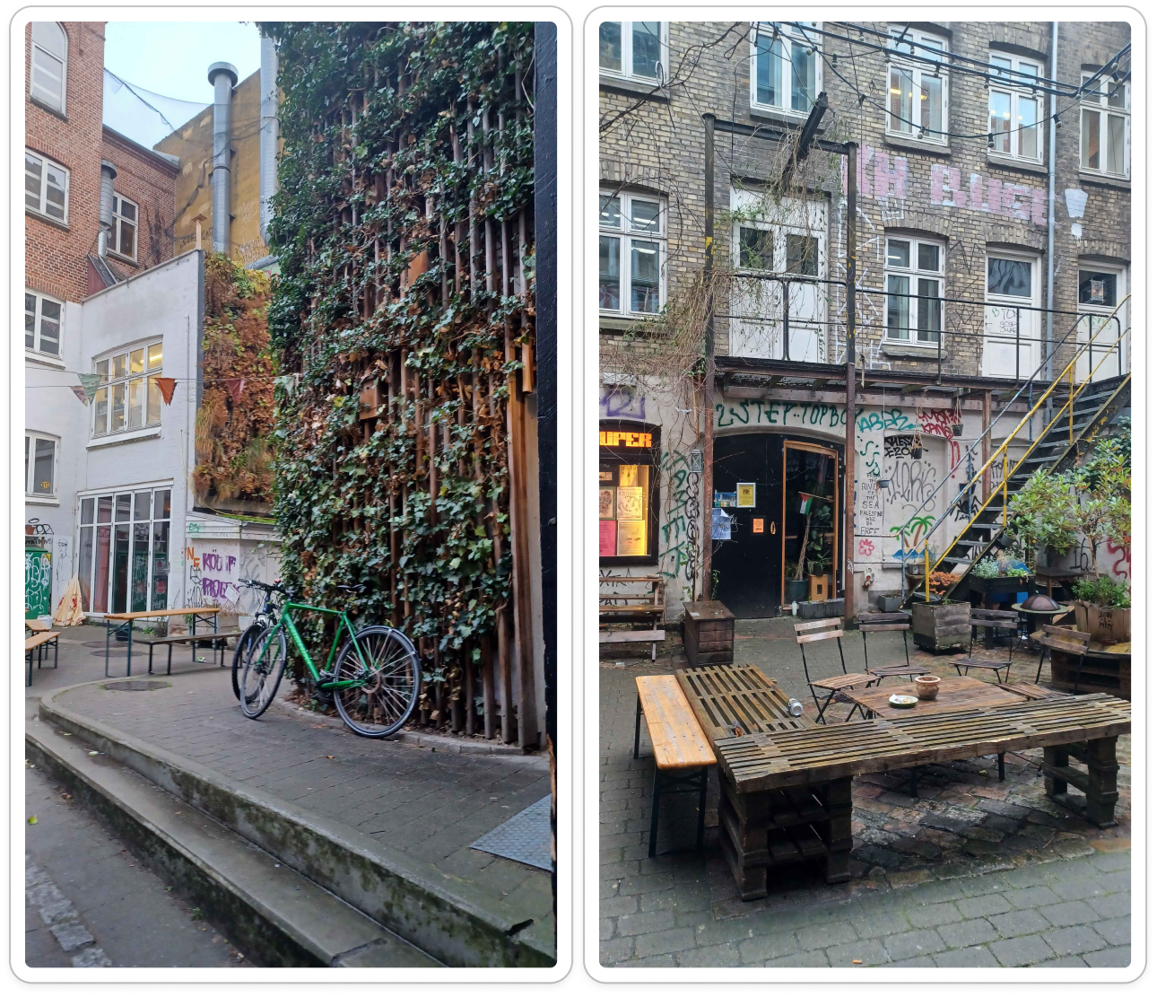

[Appendix 1: Images of courtyard - Café Mellemfolk]

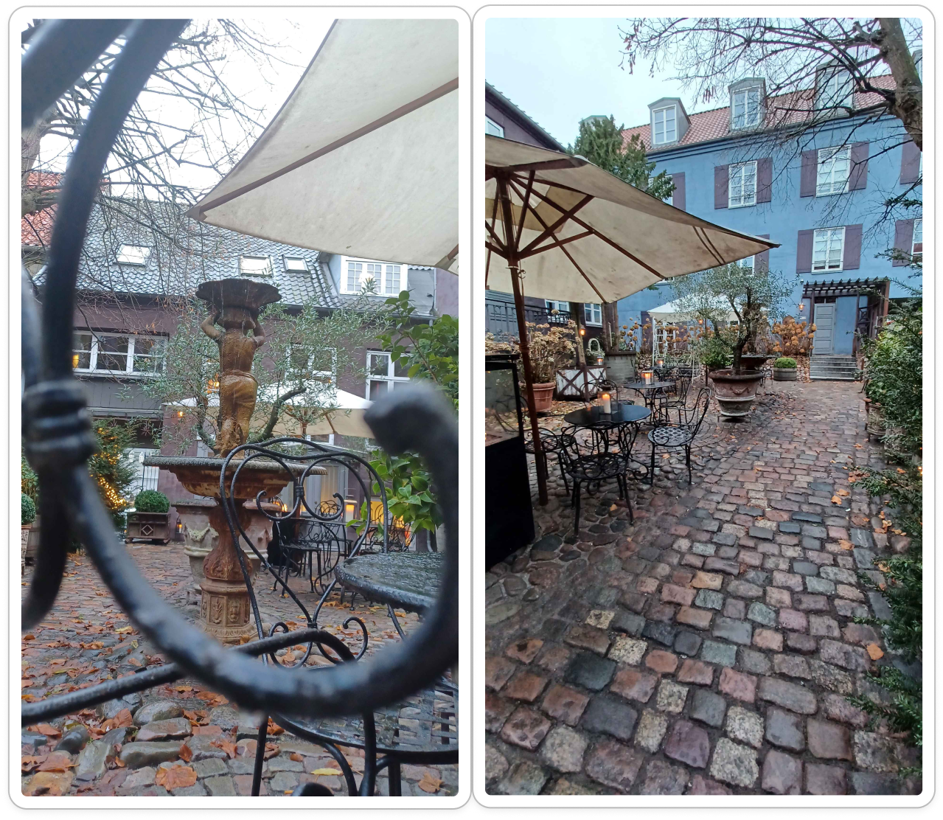

[Appendix 2: Images of courtyard - Villa Provence Hotel]

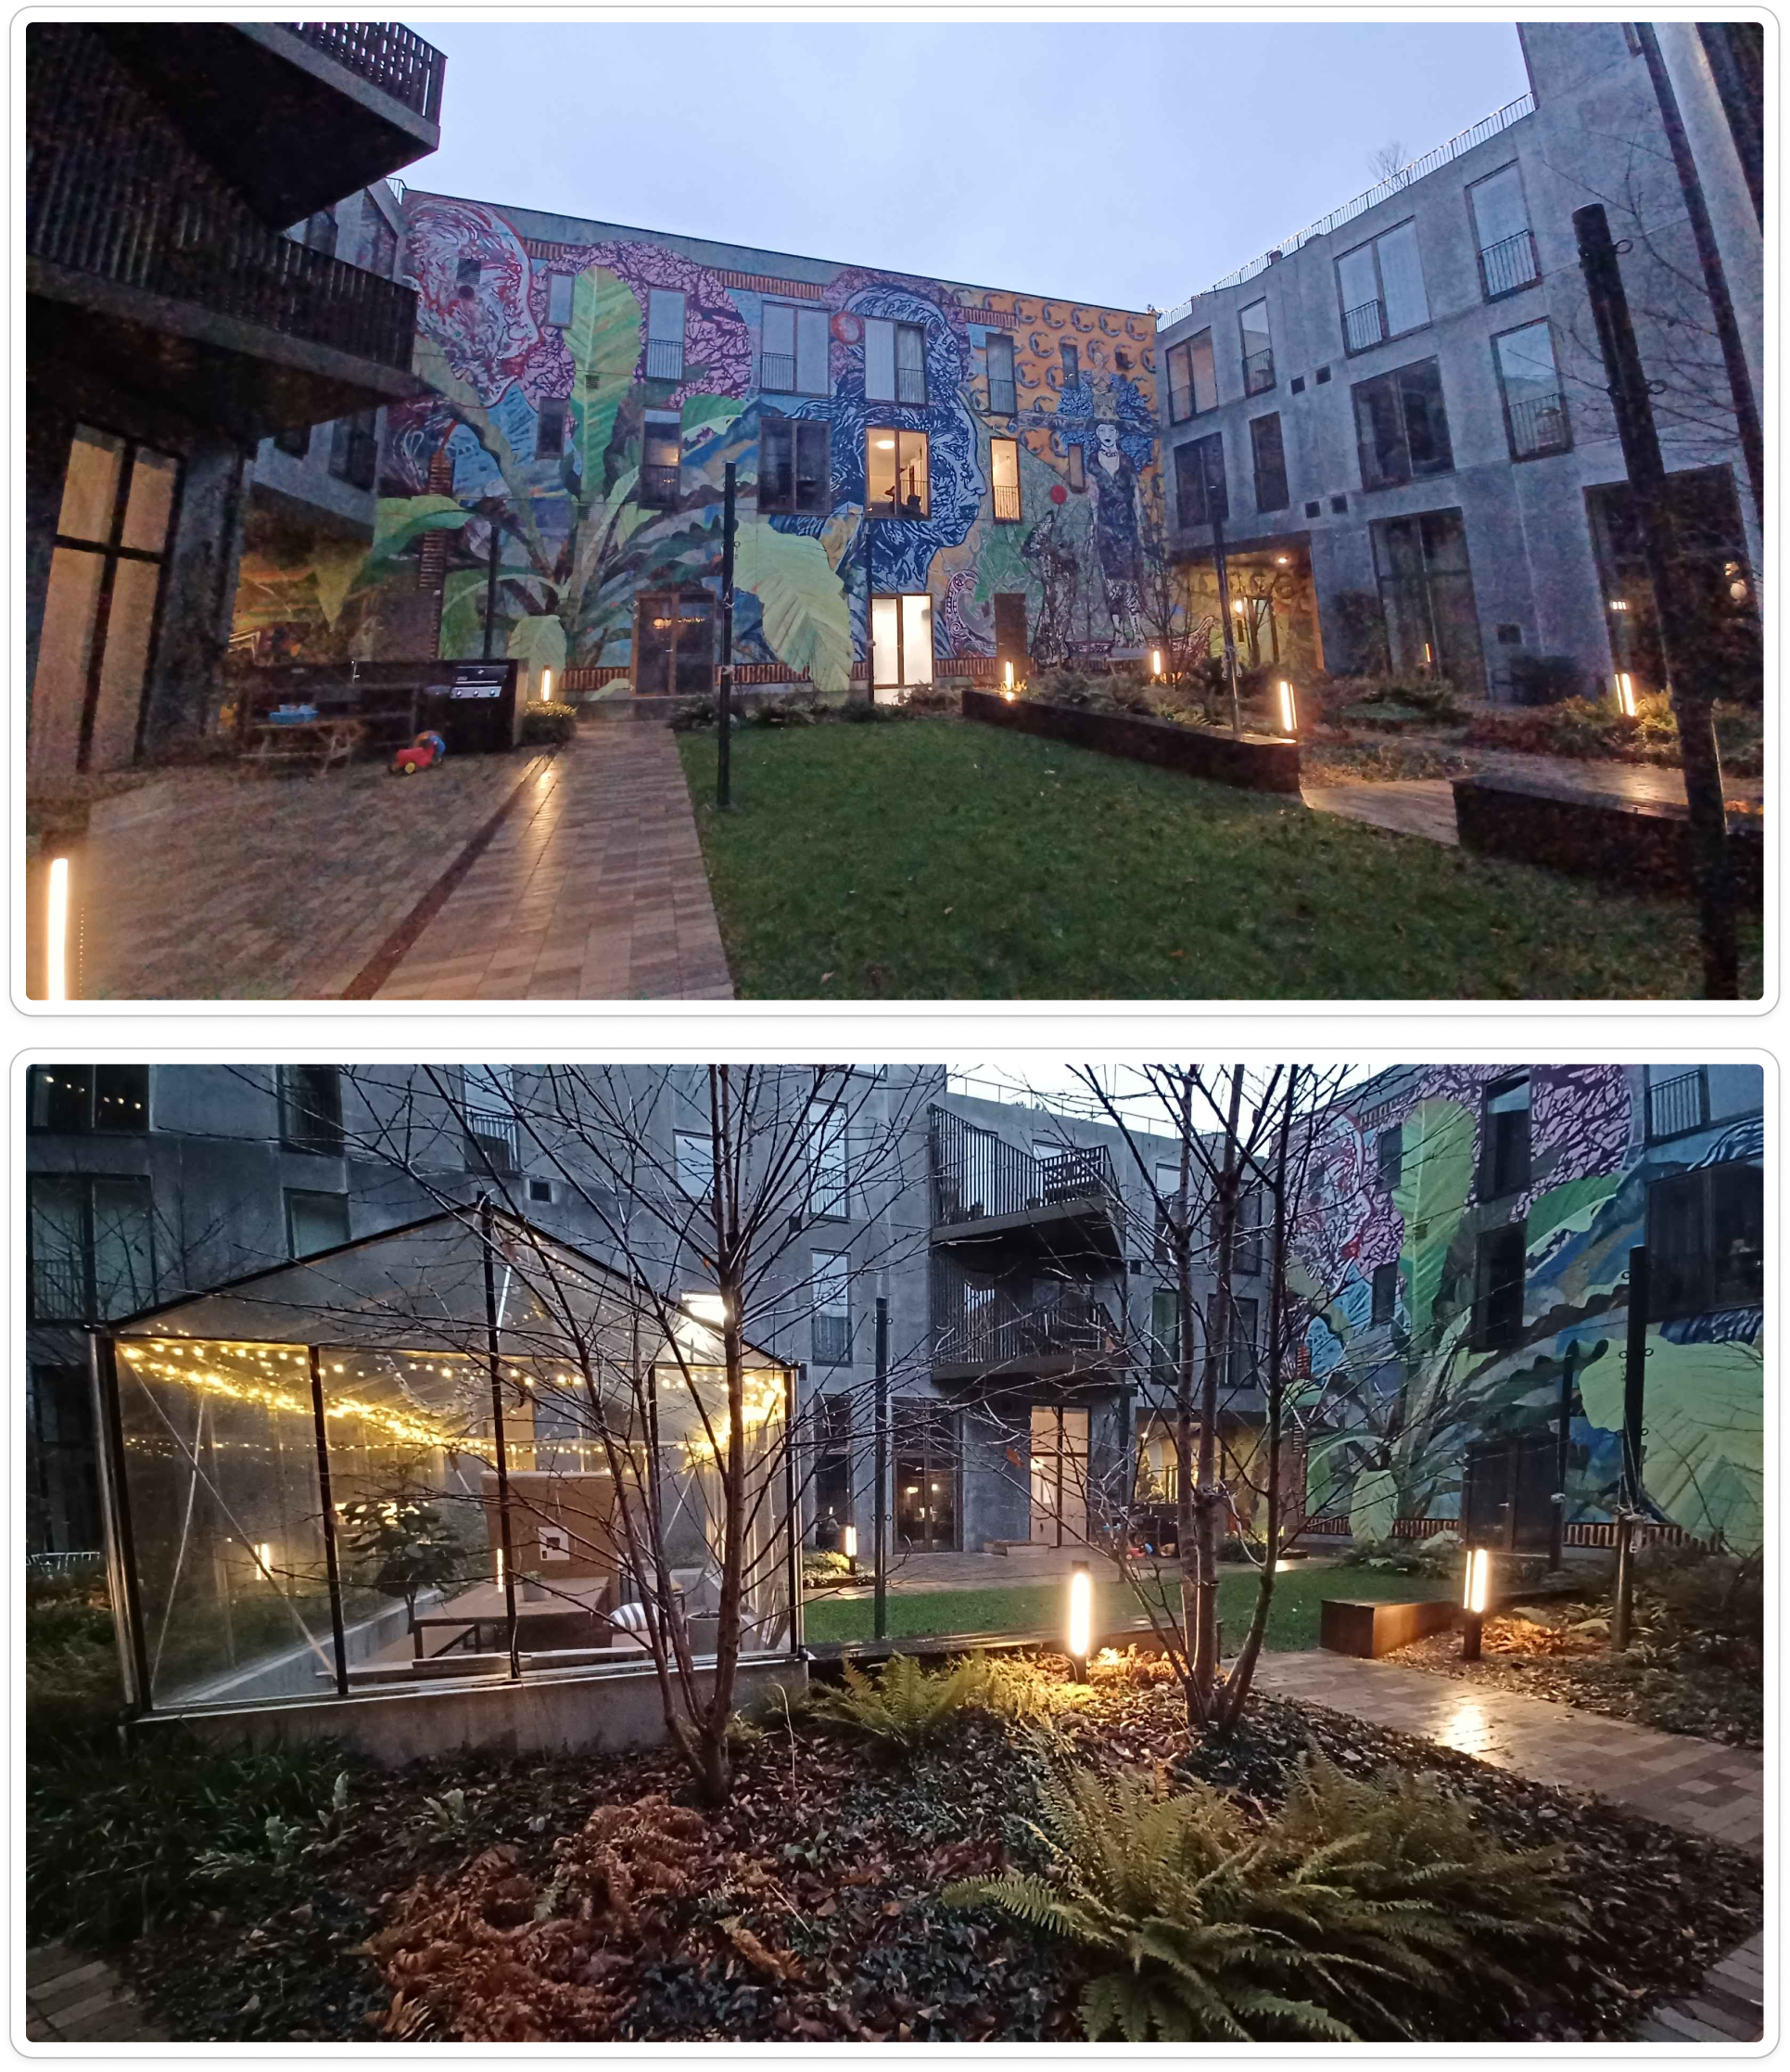

[Appendix 3: Images of courtyard - Irma Pedersens Gade 84]

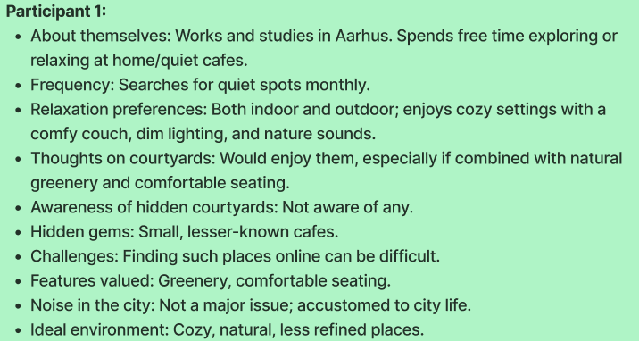

[Appendix 4: Interview participant 1]

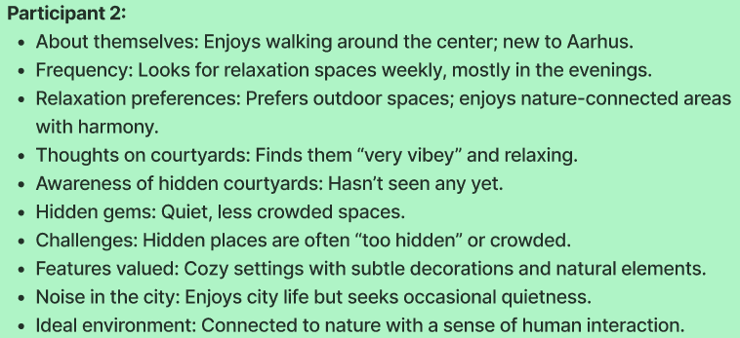

[Appendix 5: Interview participant 2]

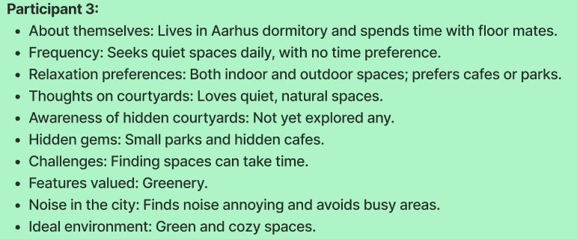

[Appendix 6: Interview participant 3]

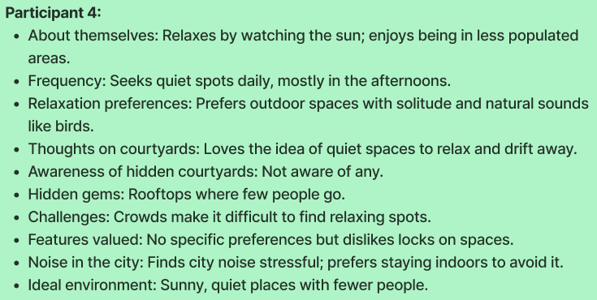

[Appendix 7: Interview participant 4]

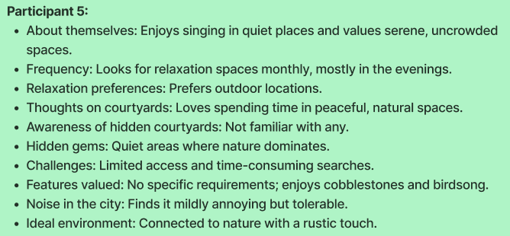

[Appendix 8: Interview participant 5]

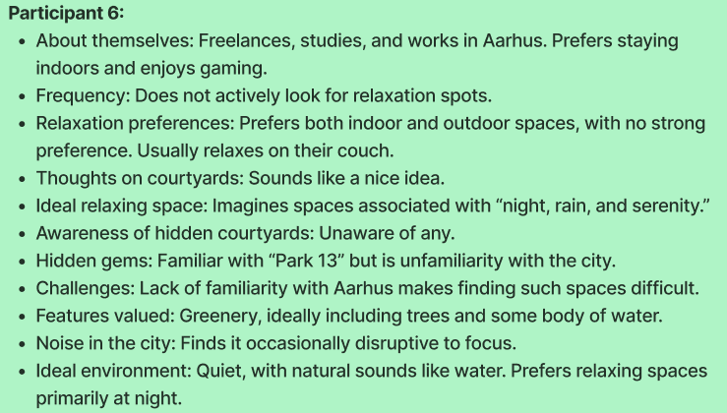

[Appendix 9: Interview participant 6]

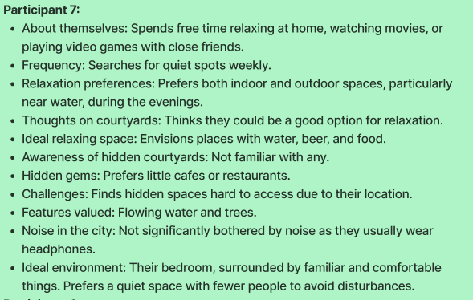

[Appendix 10: Interview participant 7]

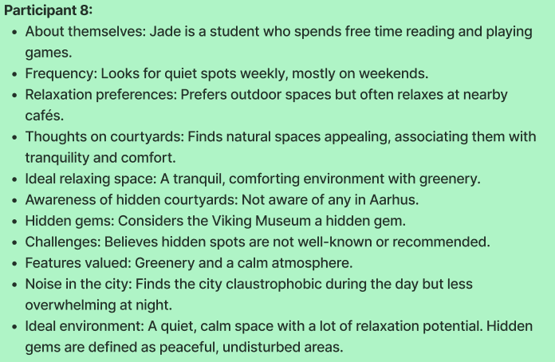

[Appendix 11: Interview participant 8]

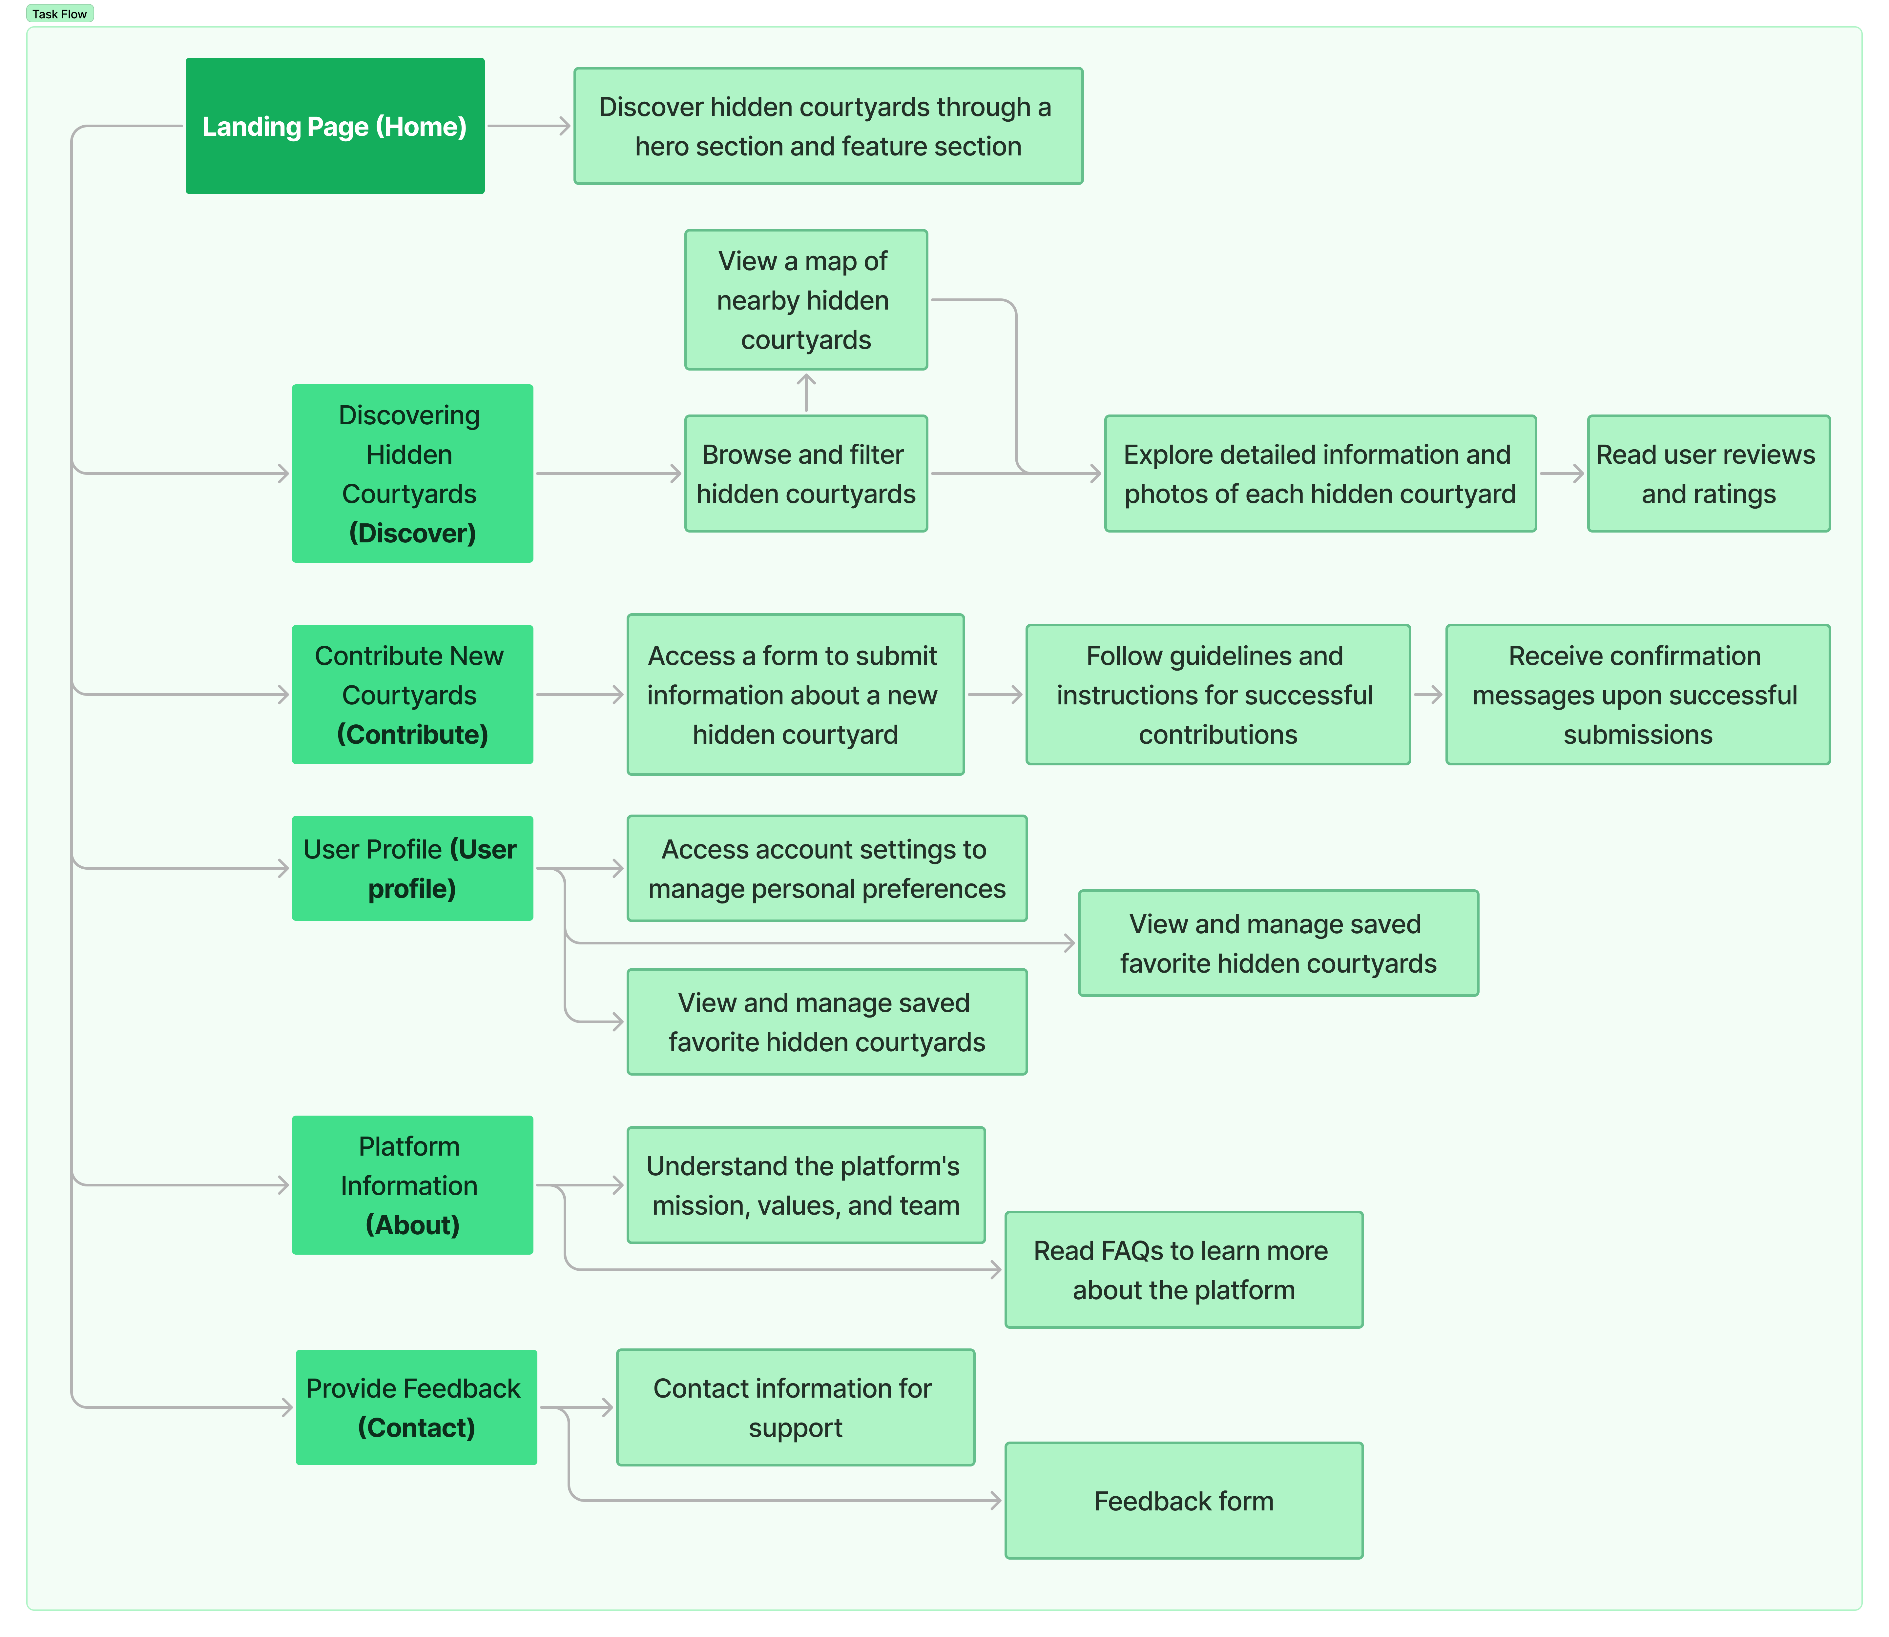

[Appendix 12: Task Flow]

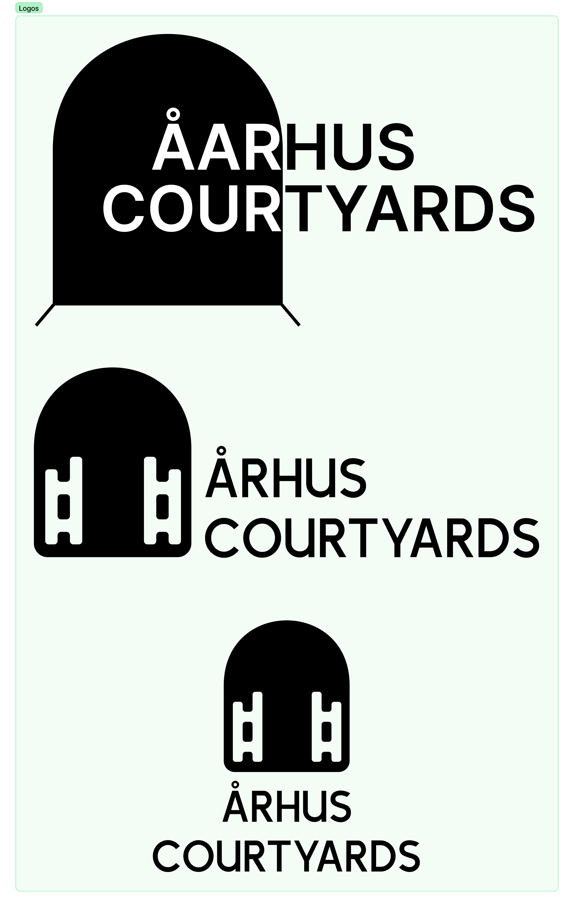

[Appendix 13: Temporary Logo Design]